We have been working all half term at creating a repeating dinosaur pattern relief. We then wrapped rugby balls to look like dinosaur eggs and placed them in our nest. We also got out all our frozen eggs and dinosaurs and added them in. We will then watch to see if they stay frozen over night or melt into watery puddles.
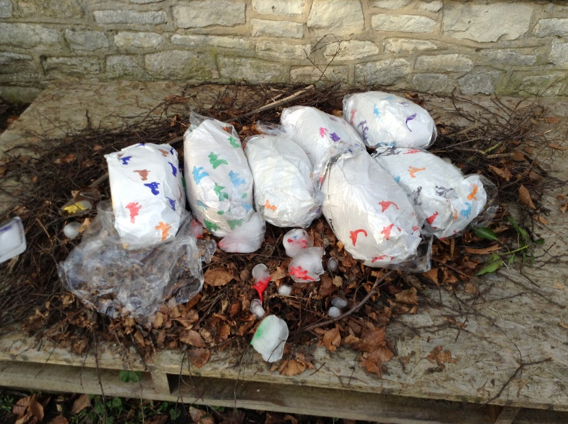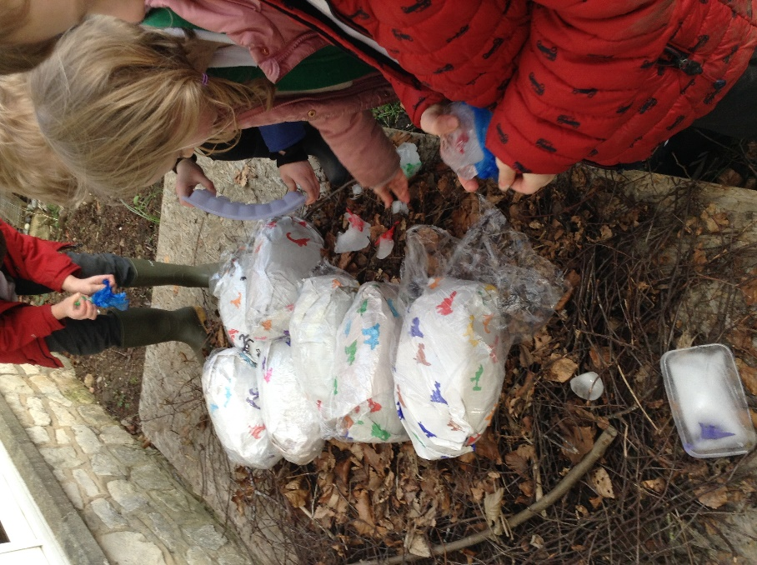

To support our homework, and to attract the only type of dinosaur we still have today, to our school environment we made bird feeders.
To do this we covered a cardboard tube in paste and then rolled them in seeds to stick. We threaded wool through the tube and practiced tying knots, this really got us to use our teamwork skills.
These are now hanging in the trees behind the classroom so we can keep bird spotting. We also filled the bird feeder and made sure they had water.
We could hear the birds tweeting and chirping. Who knows what we will see.
